**Picture Superiority Effect:**

**Pictures are remembered better than words.**

When resources like time, attention, or space are limited, pictures are one of the most effective tools a designer or educator can use to help increase retention and aid recall. Perhaps you only have so much real estate on a page for instructions, or you only have a few seconds to tell an entire story, in either case, a picture will likely convey the most meaning in the constrained environment. Images carry power. We have all heard of the value of pictures relative to words, 1:1000. The design principle which captures this phenomenon is known as the picture superiority effect, which simply states that pictures are remembered better than words. From [Advertising](https://academic.oup.com/jcr/article-abstract/11/2/643/1806532) to [Neuroscience](https://www.inc.com/carmine-gallo/neuroscience-says-this-ted-talk-rule-will-help-your-presentation-stand-out.html), the results are in and statistically conclusive. Pictures and images are easier to associate with existing knowledge and recall than words are. Think of your own experience, you see an image, it tells a story, and in the space of moments a memory is created, or one is recalled. The experience can be either positive or negative, but the effect is similar, memory creation or recall. That is not to say that words are not powerful, they certainly can be. Especially when combined with the power of pictures to create a more potent effect. However, given limited space, time, or other resources, an image will likely generate the greatest bang for the design buck.

Why do pictures have such a profound effect? The answer has to do with the way the human brain encodes, stores and recalls information. Put simply words must be encoded into visual, auditory, or semantic format before being committed to memory. When we see a word, our brains must take an additional step to process it. With familiar words and meanings, it happens below the conscious level, but the additional step is still required. Images on the other hand do not require this step, and in many cases, can be understood and remembered as seen. Additionally, that single image carries with it a great deal of context and information. The images are effectively processed in the visual cortex which is several orders of magnitude larger than other sensory brain areas. In short, our brains are [built to process images](https://www.psychologytoday.com/intl/blog/get-psyched/201207/learning-through-visuals) much more efficiently than text. Utilizing the Picture Superiority Effect in our designs and curriculum also harmonizes with [UDL](http://udlguidelines.cast.org/) principles of Recruiting Interest, Perception, Language & Symbols, and Comprehension. Additionally, this effect can harmonize well with other design principles, such as Iconic Representation, Storytelling, and Stickiness. By capitalizing on the brain’s strengths in image processing, we aid both the facilitator and the student in recalling relevant information. We have established the power and potential usefulness of the picture superiority effect, now let us look at five ways we might effectively employ it.

**Simplify complex concepts**

The natural Sciences are filled with opportunities to use the power of pictures to help students understand natural processes. Here we see 2 examples that use pictures to help visualize and understand the Water Cycle. Notice how the cycle can be relayed through pictures alone. However, through the effective use of added text and arrows, we can convey a great deal of information in one easy to understand graphic.

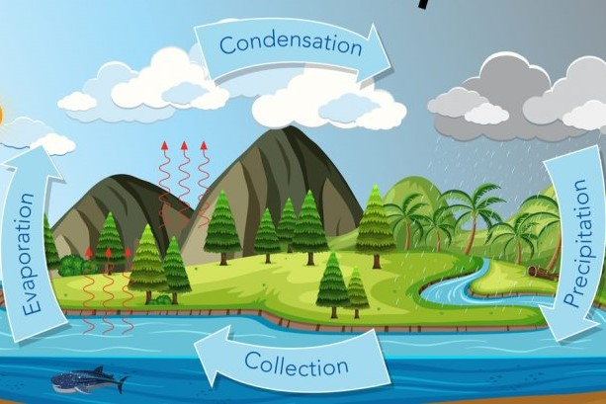

**Help visualize scale**

It's hard to grasp the size and complexity of the Large Hadron Collider at CERN, but this picture attempts to do so, with some success. I like this example because of the use of two images in one to illustrate the mechanical achievement and engineering scale at the same time. Adding a human to the tunnel for additional comparison might improve it. Nevertheless, the existing concept helps the viewer gain more of a sense than words alone would likely have done.



**Use photos to highlight differences**

We can also use comparison pictures to illustrate the presence or absence of a thing and to increase the dramatic effect. Here we see a powerful example of the effects of methamphetamine use. Note the effective layout and use of other design principles, but it is the picture-set that tells the most compelling story. I think it is interesting how easily the right kind of image can generate a visceral reaction. This poster uses several to great effect, but the single large image really brings it home.



**Pictures can enhance instructions**

The use of pictures can be invaluable when introducing new tasks or concepts involving multiple steps. This example of how to tie common bowline knot would be much less instructive without the use of pictures. I like this example in particular because of its simplicity and use of the red arrow to illustrate movement. The text-only serves to augment each step of the process, but the process can be understood with the images alone.

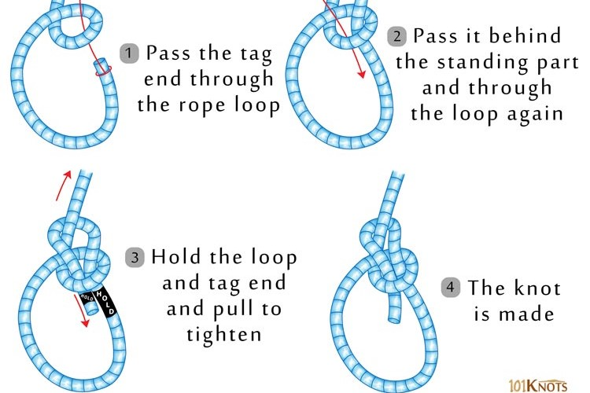

**Pictures to help tell a story**

Perhaps the most powerful attribute of a picture is its ability to tell a story. Here we see an example that illustrates some of the best and worst of our species. Pictures like the one of Tiananmen Square can be used to help students understand social concepts that may be unfamiliar. The content need not be this heavy, but it shows how complicated scenarios might become easier to deconstruct and grasp with appropriate imagery. This image also illustrates the potential power of photos, as evidenced by China’s posture towards the events surrounding. Ironically proving the very point of the protestor.

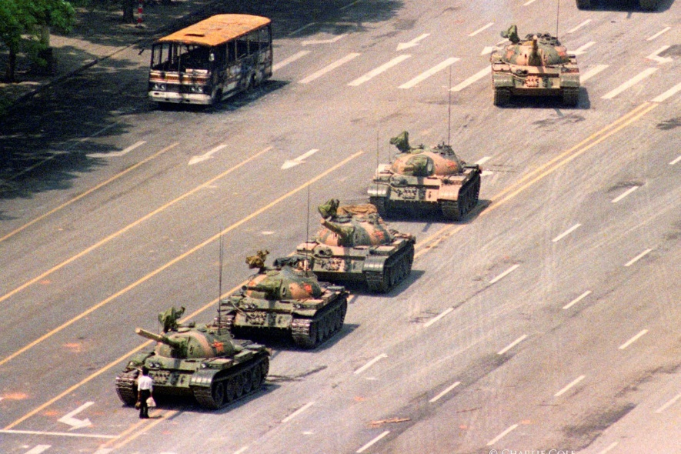

**Vision boards to see your goals**

Vision boards are personal growth visualization tools that employ the power of pictures and imagery to help users see their goals and future potential. When appropriately constructed a well-designed vision board can provide inspiration, clarity of purpose, and motivation to help its creator move towards their potential. This is a good example of effectively pairing behaviors with ideas through relevant imagery and text, without being overwhelming to look at.

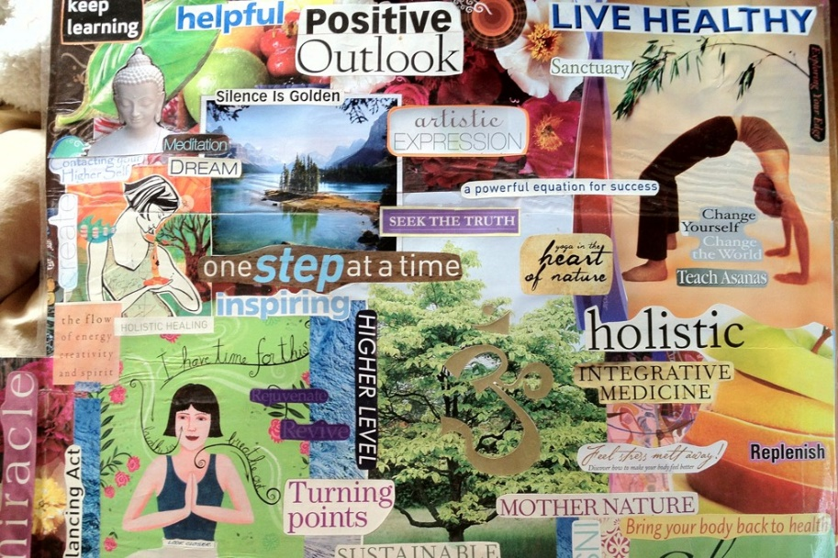

Duane Gregory - WTAMU course 6310 - Summer II - 2020